1. Code on GitHub: <https://github.com/ethanwright3/ethanwright3.github.io>
2. Methods are ARIMAX, MLPR, ELM, TBATS, GMDH, and ICD.

This assignment was excessively difficult for us to create since the paper used an ensemble of 6 different methods. So we had to try to implement each of them individually.

1. Our result:
   1. ELM:

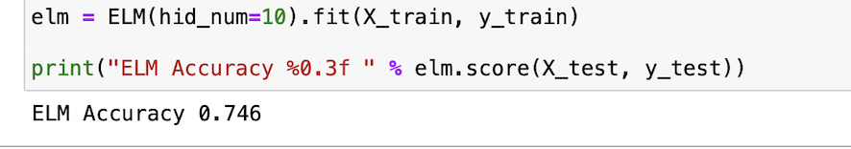

* 1. TBATS:

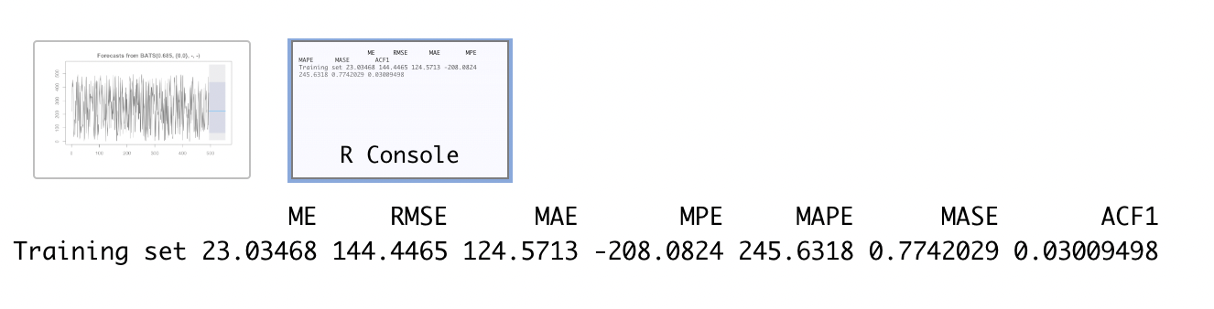

* 1. GMDH:

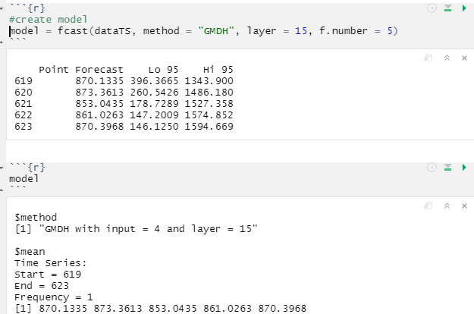

* 1. MLPR:

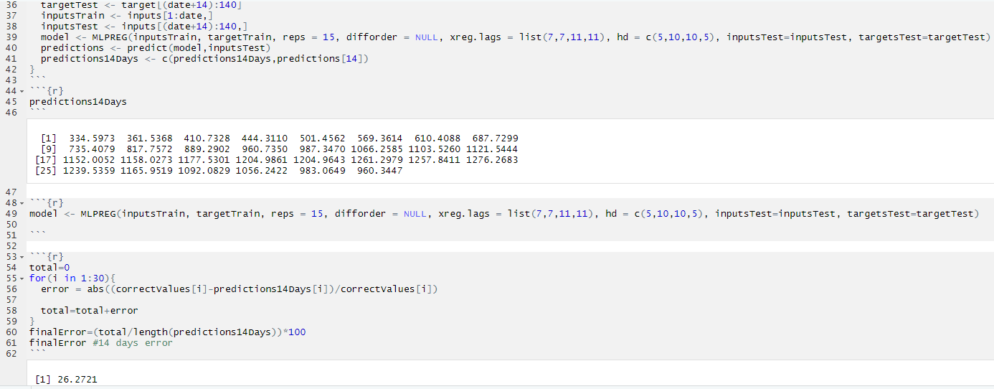

This error is for 14 days out

* 1. ARIMAX

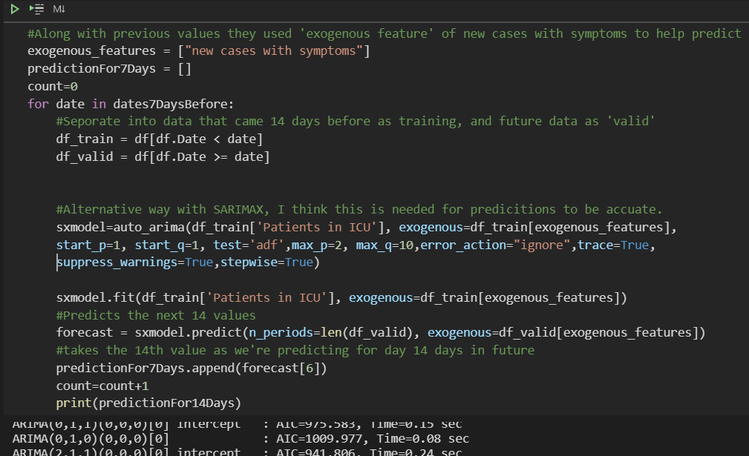

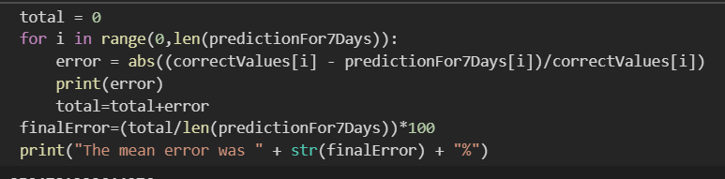

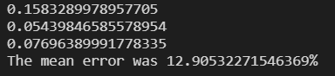This error is for 7 days out

1. Result from the paper:

7 days away

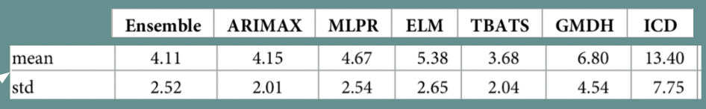

14 days away:

Since ICD doesn’t seem to have great performance, we didn’t build this model as our implementation. They also had no information for how to implement it. However, we computed all other 5 models and got similar results to the ones from the paper. For further implementation, we should probably focus on TBATS and try to improve its performance somehow.